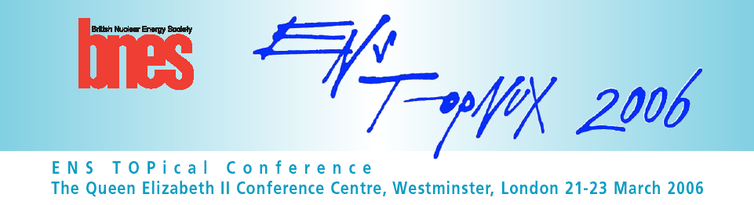

PAPER SUBMISSION FORM
Type of presentation: Poster
Submission deadline: 31 January 2006
Author notification: 15 February 2006

Choice of topic
(Please highlight the topic below you wish to contribute to)

- How countries are approaching new nuclear build
- Progress made in those countries currently constructing
- Opportunities and challenges for sustainable nuclear energy development in the 21st century
- The perception of nuclear energy in the eyes of policy makers
- Advanced reactor products, their competitive economics and prospects
- Long-term R&D and opportunities such as hydrogen production and synergies with renewables
- Skills retention, economics, regulation

Title
Authors
Affiliation

ABSTRACT
(400 words)

