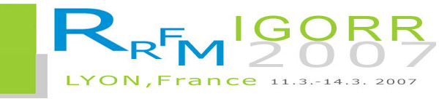 | International Topical Meeting on research Reactor Fuel Management (RRFM) – Meeting of the International Group of Reserach Reactors (IGORR) – joint meeting  Centre de Congrès – Lyon, France – 11th to 14th March 2007

TRAVEL GRANT APPLICATION FORM

(To be completed only by participants from countries on whose behalf a grant is requested)

DEADLINE FOR APPLICATION: 15 February 2007

Name: Mr/Ms/Dr/Prof. ……………………………….……. | First name: ………………………………………………….
Mailing address: ………………………………………….. | City: ......…………………………………………….……….
Area code: ………………………………………………… | Telephone: ………………………………………….………
Fax: ………………………………………………….......... | E-mail: ……………………………………….………………
Date of Birth (year/month/day): ……………….………… | Nationality: ………………………………………………….

1. Are you presenting an oral paper or poster at the conference?

 YES  NO Title: ……………………………………………………………………………..................................

2. EDUCATION (Post-Secondary)

Name and Place of Institution | Field of Study | Diploma or Degree | Years Attended
 |  |  | from | to

3. RECENT EMPLOYMENT RECORD (starting with your present post)

Name and Place of Employer/organization | Title of your position | Type of Work | Years Attended
 |  |  | from | to

4. DESCRIPTION OF WORK (performed over the last three years)

5. INSTITUTE’S / MEMBER STATE’S PROGRAMME IN FIELD OF RRFM CONFERENCE

…………………………………………………………….. | …………………………………………………………........
Date | Signature of Applicant
…………………………………………………………….. | ……………………………………………………………….
Date | Name and title (printed) and signature of  responsible Institute

