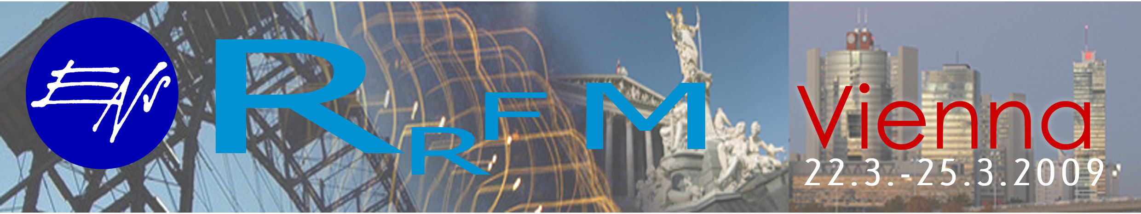
The 13th annual topical meeting on Research Reactor Fuel Management
Vienna International Centre (VIC) in Vienna, 22 to 25 March 2008

TRAVEL GRANT APPLICATION FORM

(To be sent to the competent official authority (Ministry of Foreign Affairs, national atomic energy authority) for transmission to the International Atomic Energy Agency, Vienna International Centre, Wagramer Strasse 5, P.O. Box 100, A-1400 Vienna, Austria [Telefax no. +43 1 26007]

DEADLINE FOR APPLICATION: 15 Feruary 2009

Name: Mr/Ms/Dr/Prof. ……………………………….……. | First name: ………………………………………………….
Mailing address: ………………………………………….. | City: ......…………………………………………….……….
Area code: ………………………………………………… | Telephone: ………………………………………….………
Fax: ………………………………………………….......... | E-mail: ……………………………………….………………
Date of Birth (year/month/day): ……………….………… | Nationality: ………………………………………………….

1. Are you presenting an oral paper or poster at the conference?

 YES  NO Title: ……………………………………………………………………………..................................

2. EDUCATION (Post-Secondary)

Name and Place of Institution | Field of Study | Diploma or Degree | Years Attended
 |  |  | from | to

3. RECENT EMPLOYMENT RECORD (starting with your present post)

Name and Place of Employer/organization | Title of your position | Type of Work | Years Attended
 |  |  | from | to

4. DESCRIPTION OF WORK (performed over the last three years)

5. INSTITUTE’S / MEMBER STATE’S PROGRAMME IN FIELD OF RRFM CONFERENCE

…………………………………………………………….. | …………………………………………………………........
Date | Signature of Applicant
…………………………………………………………….. | ……………………………………………………………….
Date | Name and title (printed) and signature of responsible Government official

