TITLE of paper
(ARIAL, 14 pt, all caps)

A.B. AUTHOR, C.D. AUTHOR (12 pt, all caps)
Department, Organisation (10 pt, italics)
Street, Postal Code City – Country (10 pt, italics)

E.F. AUTHOR
Other department, Other organisation (10 pt, italics)
Street, Postal Code City – Country (10 pt, italics)

ABSTRACT

Your manuscript must be in English. Please use UK spelling. We recommend limiting the abstract to 400 words but the abstract submission system allows some flexibility. To enter an abstract into the system please refer to the RRFM 2010 conference website, page ‘call for papers’; click on Abstract Submission System’ in the red box.

- Introduction (12 pt, bold)
  - Settings
Your manuscript should then continue on the same page with an introduction. The typeface throughout the text is Arial. Setting of paper size is DINA4-size only. The top, left and right margins are 2.5 cm while the bottom margin is 2 cm. For all following text sections the font size is 11 pt, single line spacing with a spacing of 0 pt before and after the paragraph mark, and the lines are justified in block mode.

  - Figures and tables

Figures and tables should be inserted into the text at the appropriate place. They should be clearly identified with a caption, as shown below.

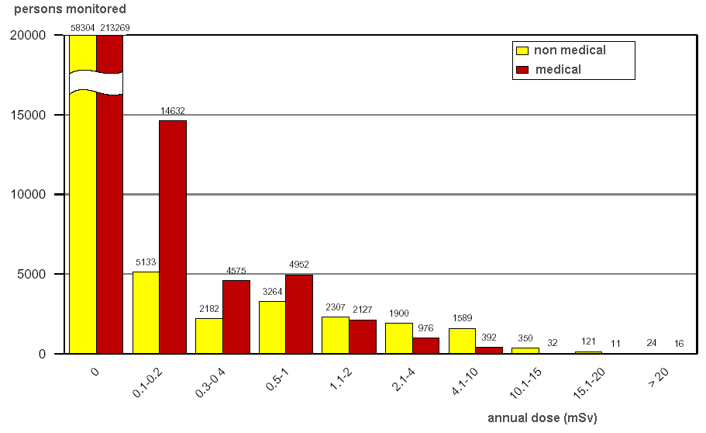
Fig 1. Caption for figure one
xxx | yyy | zzz
aaa | 123 | 456
bbb | 789 | 012
ccc | 345 | 678
ddd | 901 | 234
Tab 1: Caption for table one

- Electronic form of contribution

For the conference proceedings (Transactions) an electronic version as a MS WORD.doc file of your final paper is required. Please use UK spelling.

- Length of your presentation

Your presentation will be (exclusively) in English and not last more than 15 minutes.

The standard length of your manuscript is five pages, including the title page, all tables and figures and the references.

- Visual aids for oral presentations, special instructions for poster presentations

The visual aid available to you as a speaker in an oral session is power point projection. Posters will be on displays throughout the conference. They should be mounted on before the beginning of the first session and must be dismounted at the end of the last session. The surface available /size of the poster panels is 194 cm x 94 cm (portrait format). At least one author per paper is requested to attend personally the whole poster session to permit proper presentation and discussion of the poster during the said poster session.

- References

Please number your references and cite them in brackets. The list of references should be at the very end of your manuscript under the section heading “References”.

- Deadline

Your full paper must be sent by 19 February 2010 at the very latest. Please upload your contribution through the RRFM Abstract Submission System on www.rrfm2010.org .

Your Powerpoint presentation must be in our possession by 12 March 2010 at the very latest.

Please don't hesitate to contact the RRFM 2010 Secretariat should you have any question:
phone +32 2 505 32 58
fax +32 2 502 39 02
email rrfm2010@euronuclear.org

